**MOSFET(Metal Oxide Semiconductor Field Emitter Transistor)**

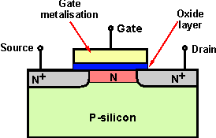

**Characterstic Curve**

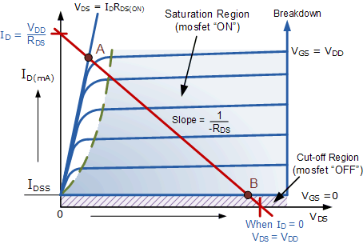

The minimum ON-state gate voltage required to ensure that the MOSFET remains “ON” when carrying the selected drain current can be determined from the V-I transfer curves above. When VIN is HIGH or equal to VDD, the MOSFET Q-point moves to point A along the load line.

The drain current ID increases to its maximum value due to a reduction in the channel resistance. ID becomes a constant value independent of VDD, and is dependent only on VGS. Therefore, the transistor behaves like a closed switch but the channel ON-resistance does not reduce fully to zero due to its RDS(on) value, but gets very small.

Likewise, when VIN is LOW or reduced to zero, the MOSFET Q-point moves from point A to point B along the load line. The channel resistance is very high so the transistor acts like an open circuit and no current flows through the channel. So if the gate voltage of the MOSFET toggles between two values, HIGH and LOW the MOSFET will behave as a “single-pole single-throw” (SPST) solid state switch and this action is defined as:

**1. Cut-off Region**

Here the operating conditions of the transistor are zero input gate voltage ( VIN ), zero drain current ID and output voltage VDS = VDD. Therefore for an enhancement type MOSFET the conductive channel is closed and the device is switched “OFF”.

**Cut-off Characteristics**

|  |  |
| --- | --- |
| mosfet switch cut-off | * • The input and Gate are grounded ( 0V ) * • Gate-source voltage less than threshold voltage VGS < VTH * • MOSFET is “OFF” ( Cut-off region ) * • No Drain current flows ( ID = 0 Amps ) * • VOUT = VDS = VDD = ”1″ * • MOSFET operates as an “open switch” |

Then we can define the cut-off region or “OFF mode” when using an e-MOSFET as a switch as being, gate voltage, VGS < VTH thus ID = 0. For a P-channel enhancement MOSFET, the Gate potential must be more positive with respect to the Source.

**2. Saturation Region**

In the saturation or linear region, the transistor will be biased so that the maximum amount of gate voltage is applied to the device which results in the channel resistance RDS(onbeing as small as possible with maximum drain current flowing through the MOSFET switch. Therefore for the enhancement type MOSFET the conductive channel is open and the device is switched “ON”.

**Saturation Characteristics**

|  |  |
| --- | --- |
| mostfet switch saturation | * • The input and Gate are connected to VDD * • Gate-source voltage is much greater than threshold voltage VGS > VTH * • MOSFET is “ON” ( saturation region ) * • Max Drain current flows ( ID = VDD / RL ) * • VDS = 0V (ideal saturation) * • Min channel resistance RDS(on) < 0.1Ω * • VOUT = VDS ≅ 0.2V due to RDS(on) * • MOSFET operates as a low resistance “closed switch” |

Then we can define the saturation region or “ON mode” when using an e-MOSFET as a switch as gate-source voltage, VGS > VTH thus ID = Maximum. For a P-channel enhancement MOSFET, the Gate potential must be more negative with respect to the Source.

By applying a suitable drive voltage to the gate of an FET, the resistance of the drain-source channel, RDS(on) can be varied from an “OFF-resistance” of many hundreds of kΩ, effectively an open circuit, to an “ON-resistance” of less than 1Ω, effectively acting as a short circuit.

When using the MOSFET as a switch we can drive the MOSFET to turn “ON” faster or slower, or pass high or low currents. This ability to turn the power MOSFET “ON” and “OFF” allows the device to be used as a very efficient switch with switching speeds much faster than standard bipolar junction transistors.

**MOSFET As Switch**

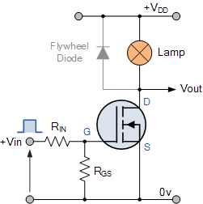

In this circuit arrangement an Enhancement-mode N-channel MOSFET is being used to switch a simple lamp “ON” and “OFF” (could also be an LED).

The gate input voltage VGS is taken to an appropriate positive voltage level to turn the device and therefore the lamp load either “ON”, ( VGS = +ve ) or at a zero voltage level that turns the device “OFF”, ( VGS = 0V ).

If the resistive load of the lamp was to be replaced by an inductive load such as a coil, solenoid or relay a “flywheel diode” would be required in parallel with the load to protect the MOSFET from any self generated back-emf.

Above shows a very simple circuit for switching a resistive load such as a lamp or LED. But when using power MOSFETs to switch either inductive or capacitive loads some form of protection is required to prevent the MOSFET device from becoming damaged. Driving an inductive load has the opposite effect from driving a capacitive load.

For example, a capacitor without an electrical charge is a short circuit, resulting in a high “inrush” of current and when we remove the voltage from an inductive load we have a large reverse voltage build up as the magnetic field collapses, resulting in an induced back-emf in the windings of the inductor.

Then we can summarise the switching characteristics of both the N-channel and P-channel type MOSFET within the following table.

|  |  |  |  |
| --- | --- | --- | --- |
| MOSFET Type | VGS (+ve) | VGS (0V) | VGS (-ve) |
| N-channel Enhancement | ON | OFF | OFF |
| N-channel Depletion | ON | ON | OFF |
| P-channel Enhancement | OFF | OFF | ON |
| P-channel Depletion | OFF | ON | ON |

Note that unlike the N-channel MOSFET whose gate terminal must be made more positive (attracting electrons) than the source to allow current to flow through the channel, the conduction through the P-channel MOSFET is due to the flow of holes. That is the gate terminal of a P-channel MOSFET must be made more negative than the source and will only stop conducting (cut-off) until the gate is more positive than the source.

So for the enhancement type power MOSFET to operate as an analogue switching device, it needs to be switched between its “Cut-off Region” where: VGS = 0V (or VGS = -ve) and its “Saturation Region” where: VGS(on) = +ve. The power dissipated in the MOSFET ( PD ) depends upon the current flowing through the channel ID at saturation and also the “ON-resistance” of the channel given as RDS(on).

**DEVICE OTHER THAN MOSFET WHICH CAN BE USED**

**TFET**

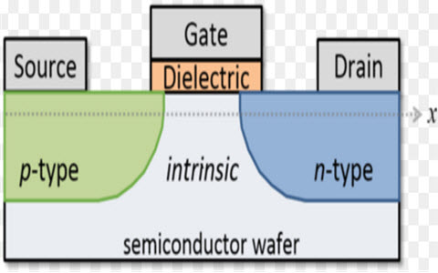

**TFET**

The term TFET stands for tunneling field effect transistor, that has been developed in the year 1992 by T. Baba, as one of the capable changes to the conventional MOSFET’s based on numerous performance factors includes Possible for above the 60mV/decade, sub threshold swing, ultra-low power & ultra-low voltage, the effects of short channel, leakage current reduction, speed requirement exceeding due to the effects of tunneling, capability to work on sub-threshold and super-threshold voltage, similarity in the assembly process as equated with a MOSFET. Taking into attention the above factors, [the MOSFET](http://www.edgefxkits.com/blog/power-mosfet-basics-working-principle-applications/)could be changed by a potential substitute in terms of tunneling field effect transistor for the purpose of high-speed, energy efficient , and ultra-low power applications in the area of integrated circuits.

**BASICS OF TFET**

Tunneling field effect transistor (TFET) is a one type of upcoming emerging device. Generally, a [MOSFET is used for low energy electronic devices](http://www.edgefxkits.com/blog/types-of-mosfet-applications/). The structure of the tunneling field effect transistor is almost closer to the MOSFET, but, with different important switching mechanism. The switching mechanism of TFET is done by modulating quantum tunneling through a barrier in its place of modulating thermionic emission over a barrier as in traditional MOSFETs.

This transistor is a three terminal or four terminal device built in Si (silicon). The working principle of this transistor is gate-controlled band to band tunneling and its basic structure is a gated PIN diode. Compared to the MOSFET, it has numerous advantages like apt for low power applications due to lower outflow current, better immunity to short channel effects, sub threshold swing is not restricted to 60mV/decade, greater operating speed due to tunneling, the threshold voltage is much smaller, the current ratio is low off and higher on/off. Thus, TFET can be thought as a capable alternative to the MOSFET for low power and high-speed applications.

### TFET Construction

In the last few years there has been a rising demand for the [TFET (Tunnel field effect transistor)](http://www.edgefxkits.com/blog/tunnel-field-effect-transistor/) and researchers are doing a wide study on this transistor. Absolutely there must be a component with the TFET due to which it has involved huge attention of everyone. And here we will give you an overview of the Tunneling field effect transistor.

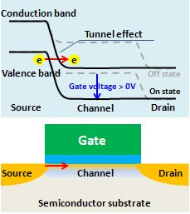

**TFET Construction**

The basic construction of TFET is similar to a MOSFET excluding that the both source and drain terminals of a TFET are doped of reverse type. A common tunneling field effect transistor device structure consists of a PIN junction (p-type, intrinsic, n-type), in which the electrostatic potential of the intrinsic area is controlled by a gate terminal.

The TFET device is functioned by applying gate bias so that electron buildup occurs in the intrinsic section. At ample gate bias, BTBT (band-to-band tunneling) happens when the conduction band of the intrinsic region brings into line with the valence band of the P-region.

In valance band, the flow of electrons In the p type region channel into the conduction band of the intrinsic region and the flow of current across the device. As the gate terminal bias is reduced, the bands develop misaligned and the flow of current is no longer flow

After having a wider research and study on the TFET (Tunneling field effect transistor) it can be decided that the source channel tunneling process in doping less TFET can be measured by a gate voltage and the similar idea is also applied in case of other transistors also.

Drain current Vs gate voltage for theoretical TFET and MOSFET devices. The TFET may be able to reach higher drain current for small voltages.

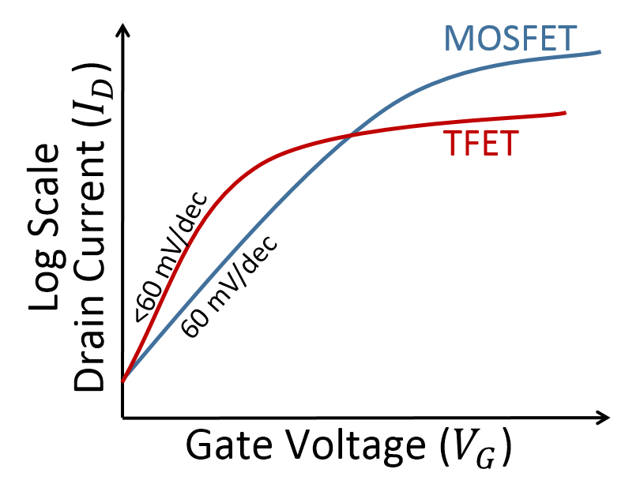

**Transfer Characteristics of TFET**

Last but not the least the TFET is absolutely protected to random dopant variations and it has been a significant feature for this transistor. The add on point of this transistor is that it does not need very high thermal resources and it can achieve the thermal budget at a very slight one. From the current features of the TFET, it can be detected and estimated that in upcoming a lot work and progress can be expected from this.

#### **Applications of TFET**

TFET or tunnel FETS are similar to MOSFETs and applications of these two are similar like a digital switch, etc. The working principle of TFETs is quite different than MOSFETs. In MOSFETs, the flow of current will be due to diffusion phenomenon, while in Tunnel FETs, the conduction mechanism is allied to Zener Tunneling.

The TFET belongs to the family of so-called steep slope devices that are presently being examined for ultra-low-power electronic applications

Because of their low-off currents, they are perfectly suitable for low-standby-power logic and low-power applications which are functioning at moderate frequencies. Other applications of tunnel FETS include ultra low-power specific analog ICs (integrated circuits) with better temperature strength and low-power SRAM.

The main advantages of TFETs include the following

* Having Less SS<60 mV/decade.
* Low power requirement